Hypothesis testing

**Level of confidence (c)** 🡪 tells us how sure we are , we have made the right thing.  
Eg:99% confidence, we decided to reject the null hypothesis. Then it is concluded it is 99% sure with certainty that rejecting null hypothesis was correct.  
Eg : If 50% of confidence, then we decided to reject the null hypothesis, then who is going to believe this???   
If the level of confidence is higher than 90%, then only believing the null/alternate hypothesis can be concluded.

**Level of significance** ( ) 🡪 1-level of confidence.  
if Level of confidence 🡪 95%, then c=0.95  
level of significance 🡪 1 – c 🡪 1 – 0.95 🡪 0.05



**Level of significance and level of confidence is concluding that How sure are we making the right decision or not all.**

**P-value method :**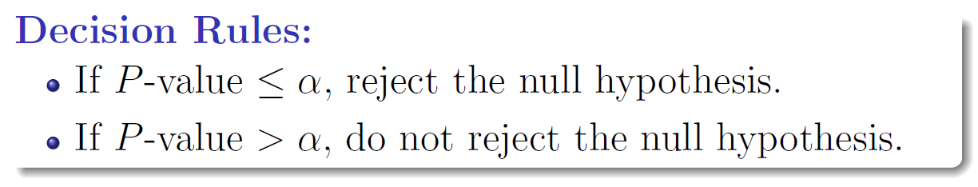

**Standard Normal Distribution Table**

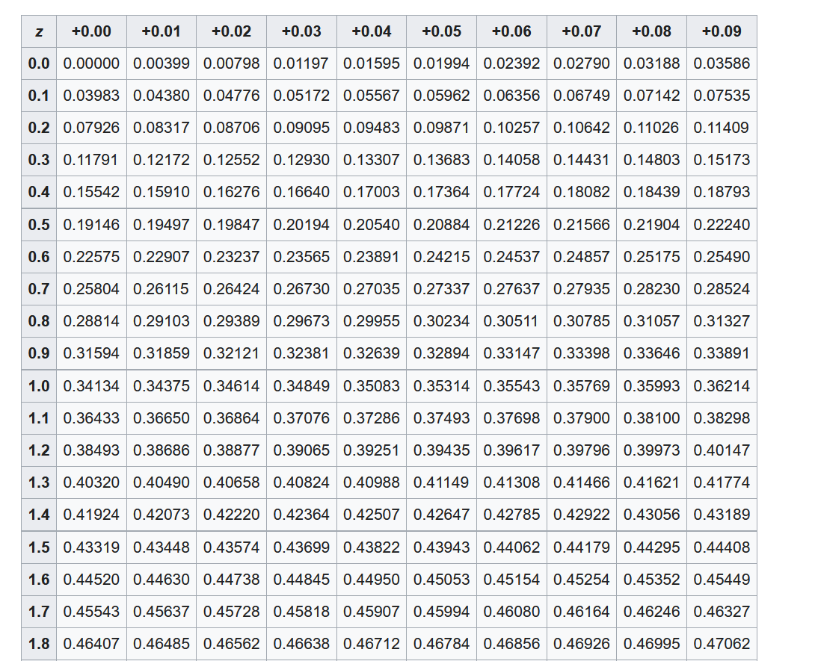 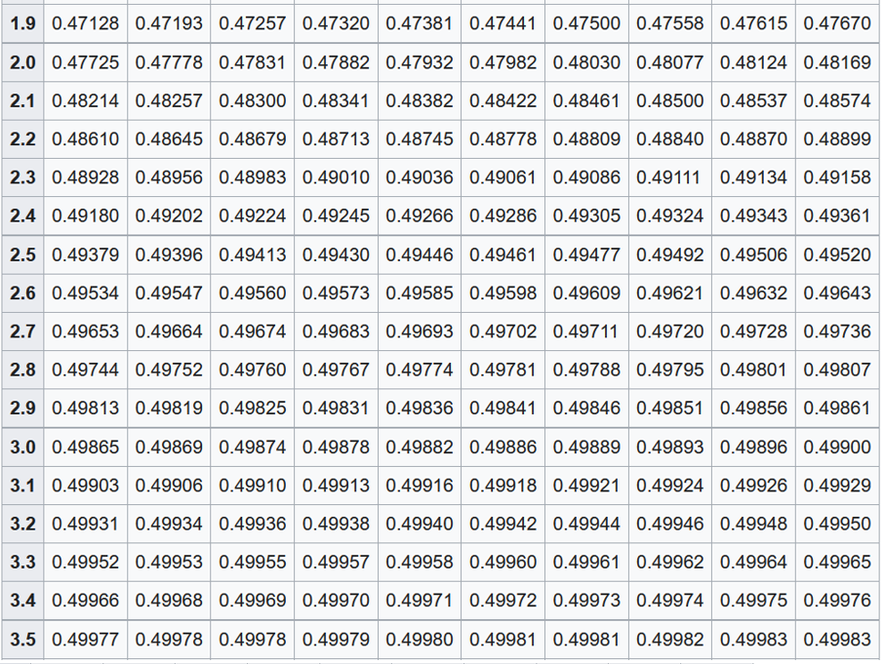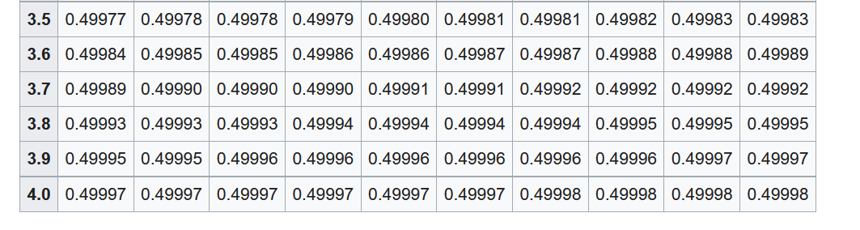

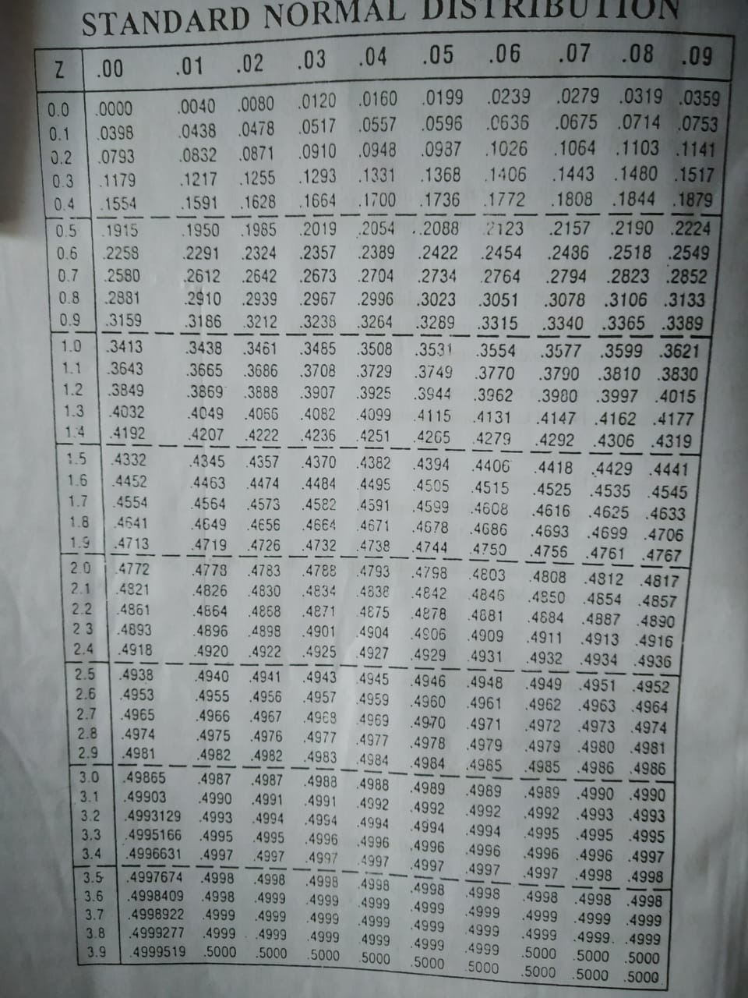



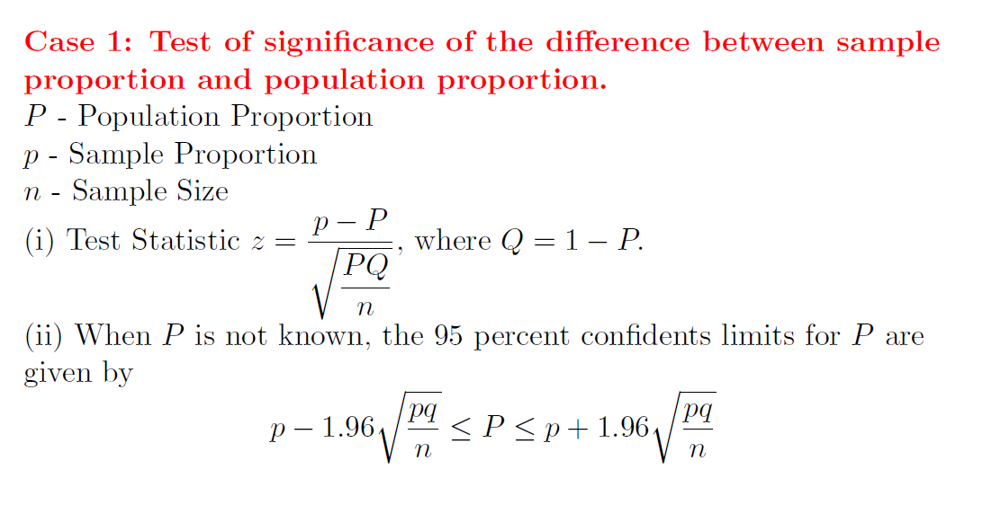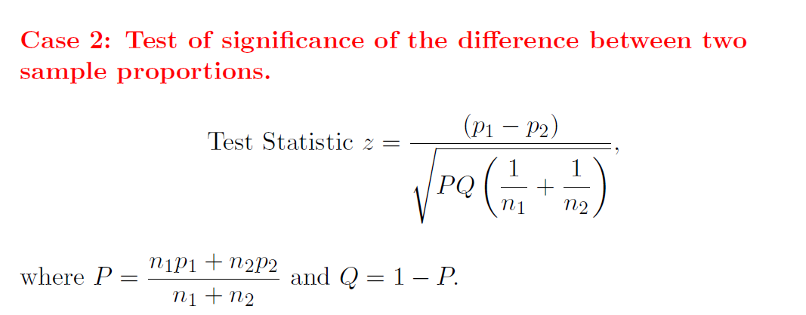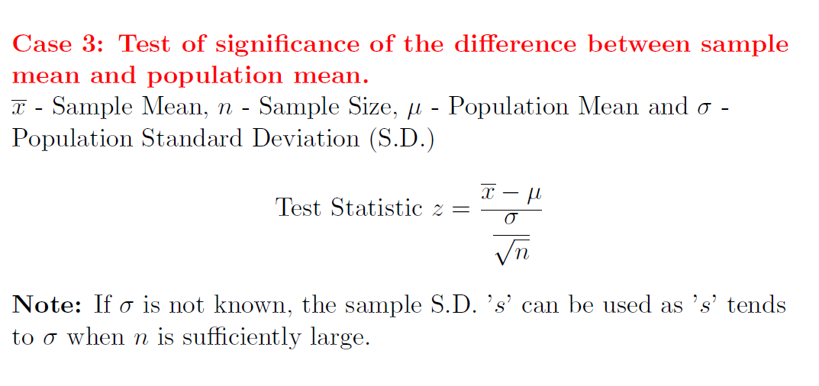

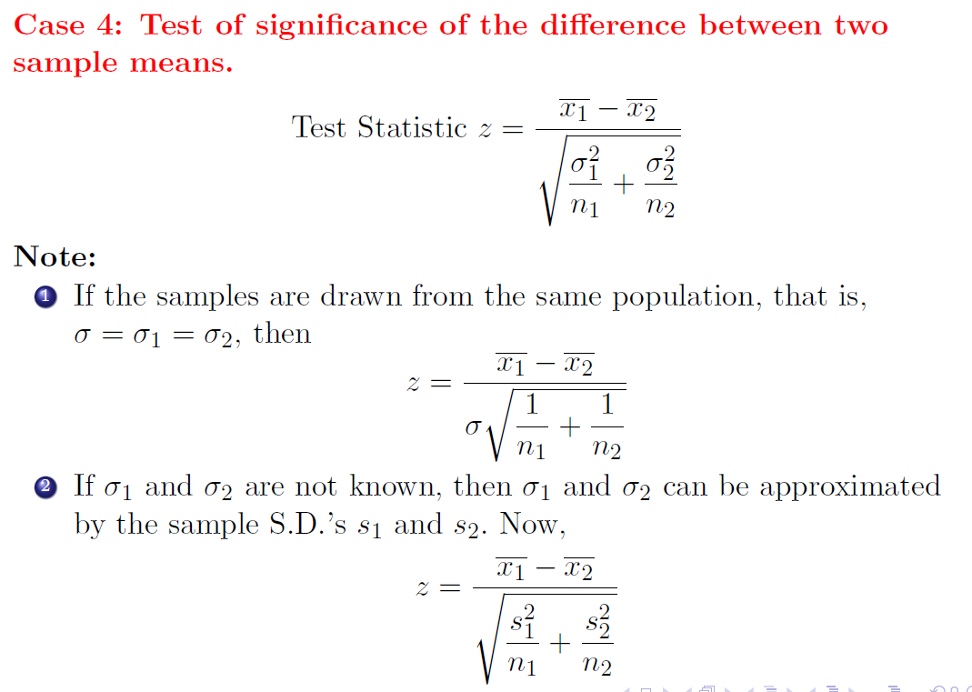

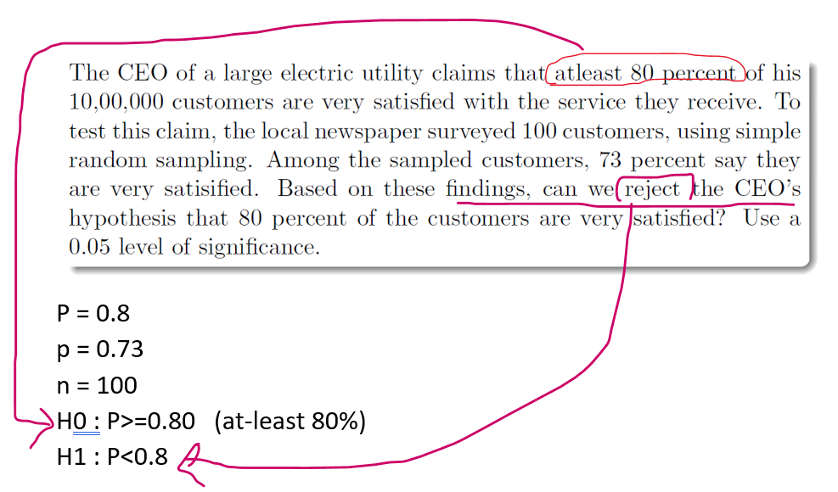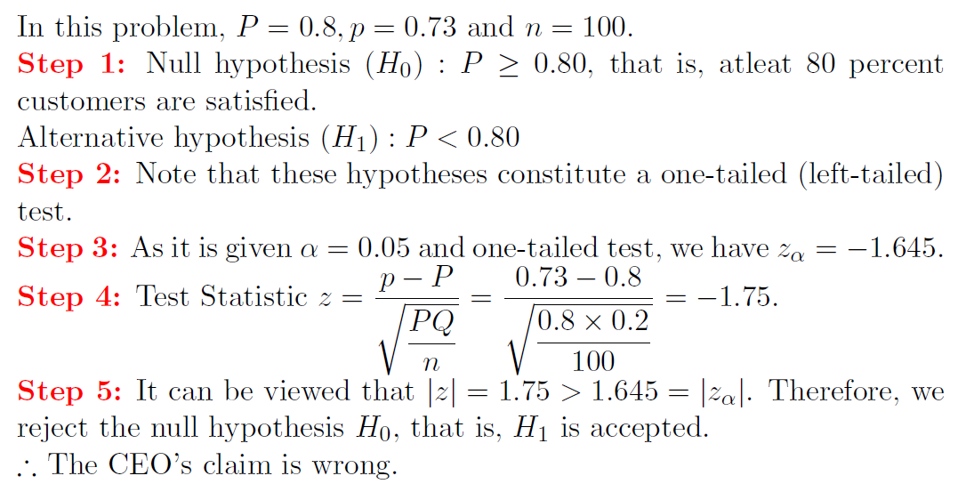



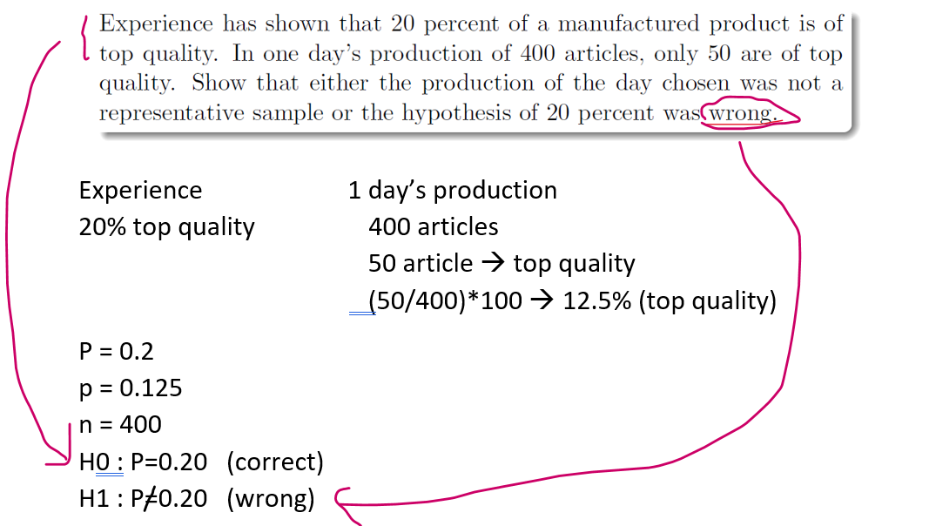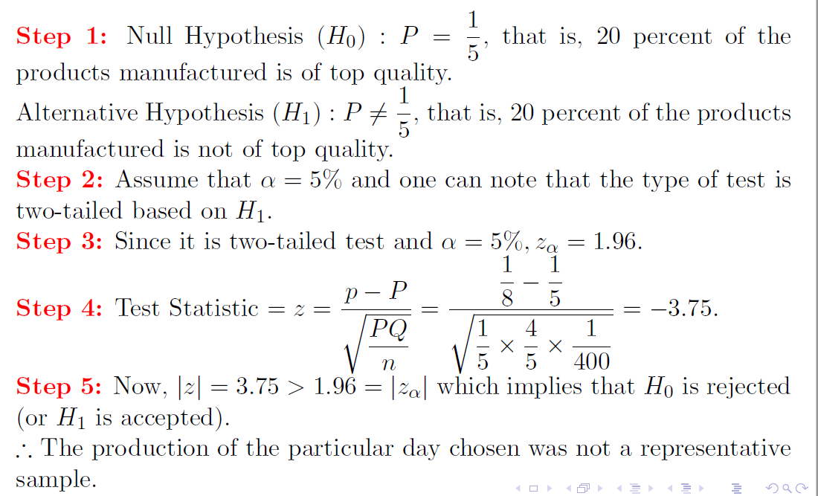



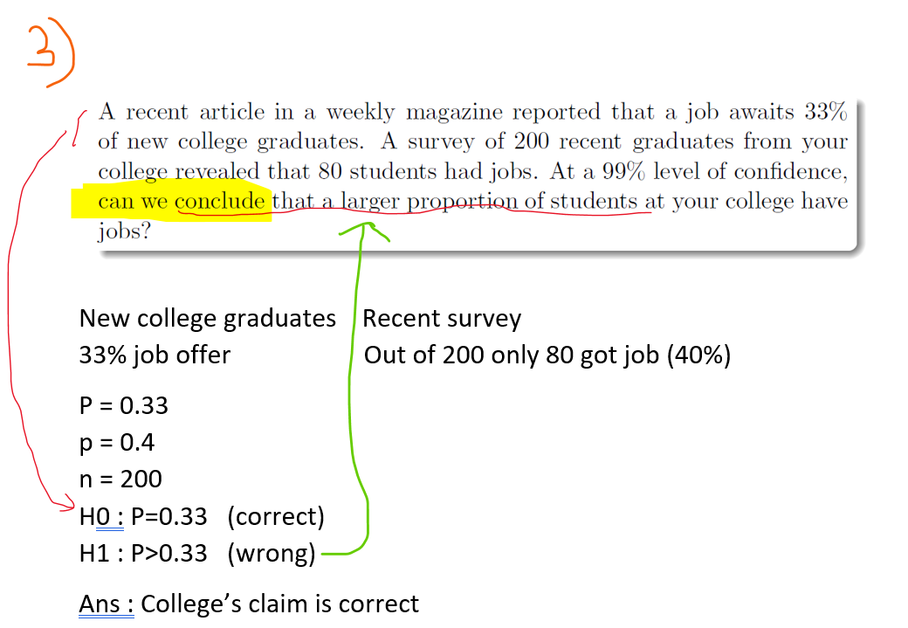



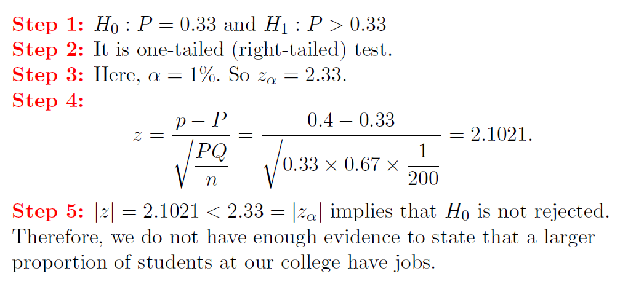

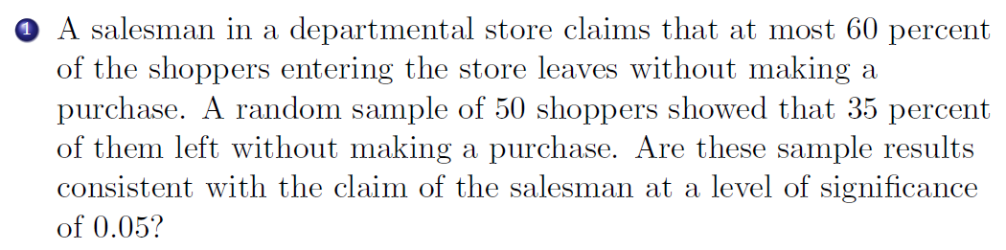

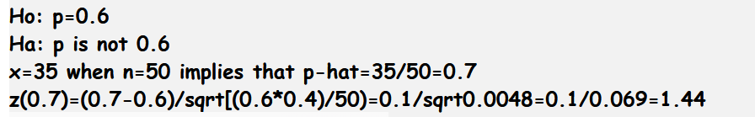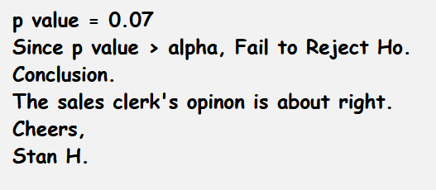

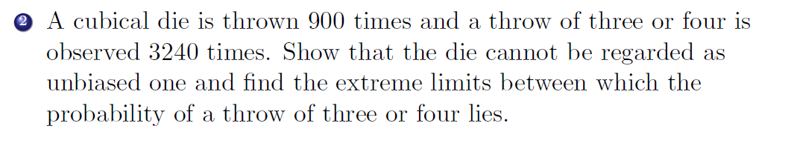

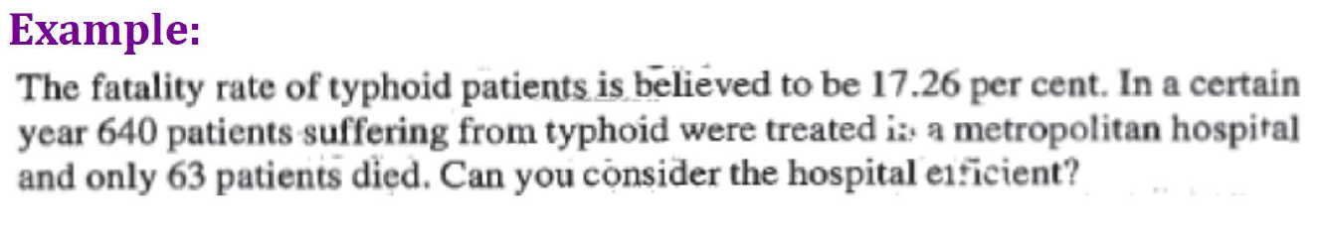­­

General Metropolitan Hospital   
Death 🡪 17.26% 640 patients   
 63 died (63/640)*100 🡪 9.8%

P = 0.1726  
p = 0.098  
n = 640  
H0 : P=0.1726 (believed)  
H1 : P>p (Efficient hospital 🡪 When the death rate of the hospital is low )

Ans : Hospital is efficient

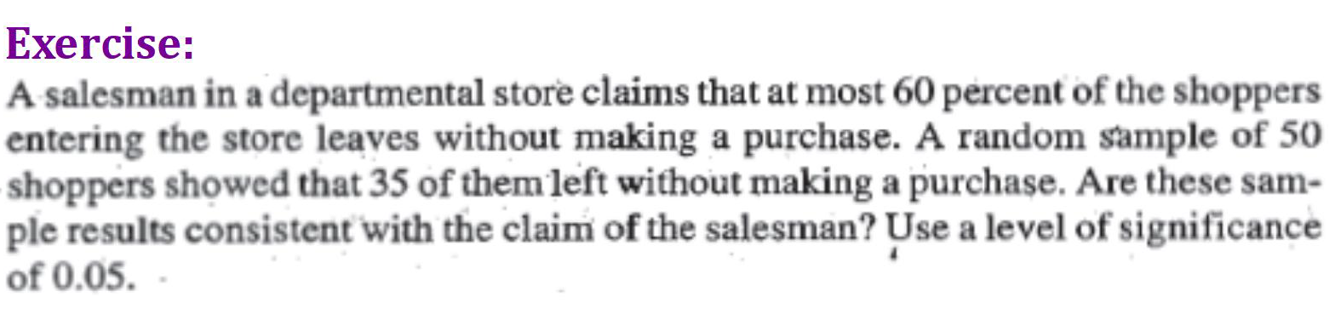



Salesman claims Random Sample   
Atmost 60% (35/50)*100 🡪 70%



P = 0.6  
p = 0.7  
n = 50  
H0 : P<=0.6 (atmost) **[p=P]**H1 : P>0.6 (without making a purchase) **[p>P]**



Ans : Sales clerk opinion is right

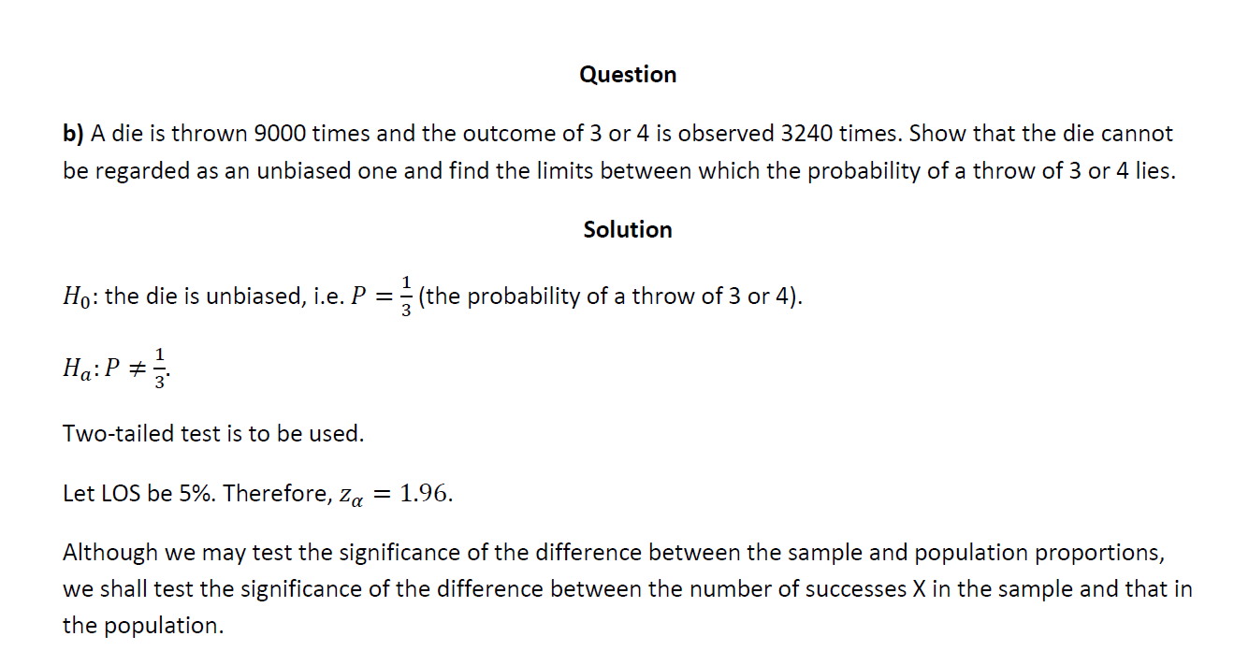  
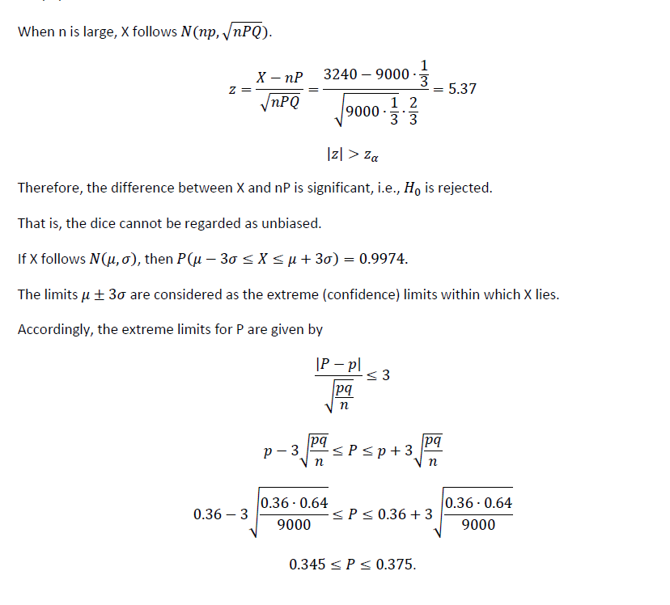

Case-2

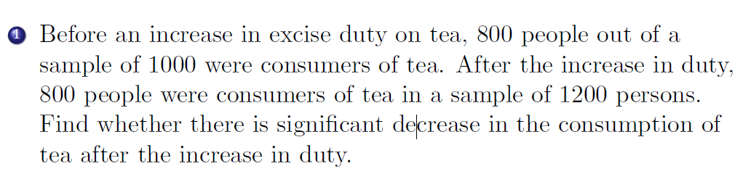

n1=1000 n2=1200  
p1 = 800/1000 🡪 0.8 p2=800/1200 🡪 0.667

H0 🡪 p1=p2  
H1 🡪 p1>p2

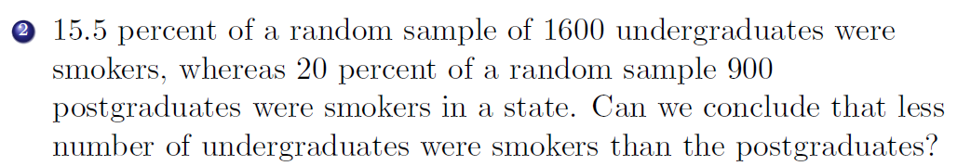P1=0.155 P2=0.2  
n1=1600 n2=900

H0 🡪 P1=P2  
H1 🡪 P1<P2

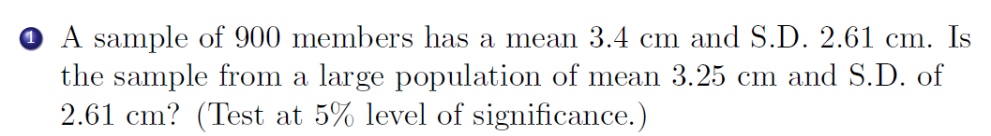

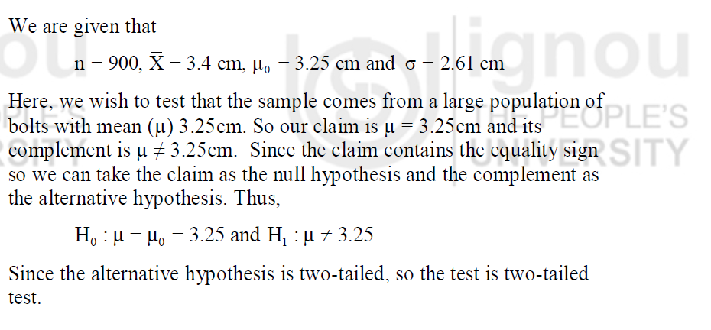  
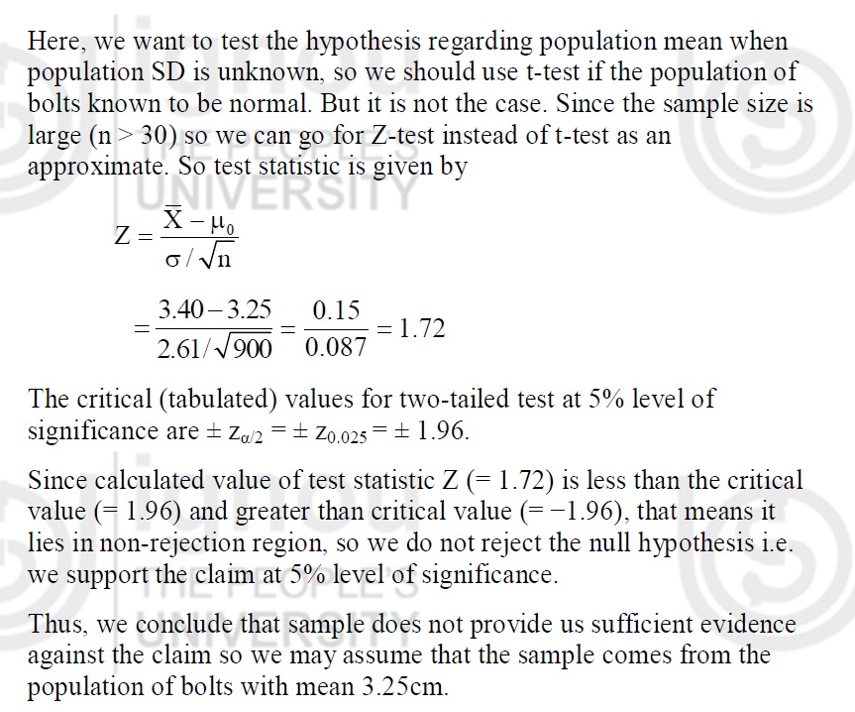



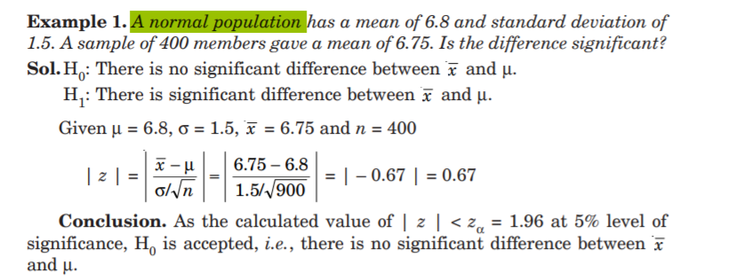

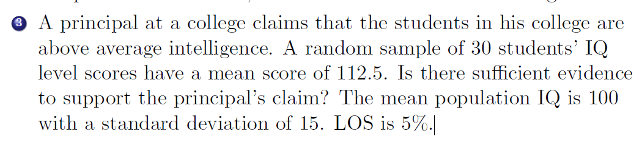

<https://fr.slideshare.net/MuhammadAnas96/ztest-with-examples>

